A Community-Wide, Coordinated Needs Assessment:
Frequently Asked Questions (FAQs)

How many assessment meetings can I attend? As many as you feel are relevant to you! There will be at least two meetings for each topic- the first will happen in the fall and the second in February and March.
When and where are the Assessment meetings? Here’s the dates and locations for the first set of meetings along with their registration links. Registration is required.

- Education: Tuesday, October 25th 2:30-5pm Gonzaga’s Cataldo Hall REGISTER: https://www.eventbrite.com/e/spokane-community-assessment-discussion-education-tickets-429917995297
- Economic Vitality: Wed, November 2nd 2:30-5pm. Location TBA REGISTER: https://www.eventbrite.com/e/spokane-community-assessment-discussion-economic-vitality-tickets-429920542917
- The Environment: Thursday, November 3rd 2:30-5pm Saranac Building REGISTER: https://www.eventbrite.com/e/community-assessment-discussion-the-environment-in-spokane-county-tickets-425351366387
- Housing: Tuesday, November 15th 2:30-5pm The Hive Library REGISTER: https://www.eventbrite.com/e/spokane-community-assessment-discussion-housing-tickets-430939962027
- Public Safety: Thursday, November 17th 2:30-5pm Downtown Central Library REGISTER: https://www.eventbrite.com/e/spokane-community-assessment-discussion-public-safety-tickets-430944054267
- Health: Wednesday, November 30th 2:30-5pm Spokane Regional Health District REGISTER: https://www.eventbrite.com/e/spokane-community-assessment-discussion-health-tickets-429922579007

What if I need support attending a meeting? We want to hear your voice and perspective. If you face barriers to participation, we have a limited number of $25 gift cards available to support your involvement. Please email SpokaneAssessment@gmail.com for details.

The assessment helps us better understand and prioritize the biggest issues facing Spokane County. Non-profit hospitals, public health, accountable communities of health, and others are required by federal law, state mandates, or agency policy to conduct assessments reviewing data every three to five years that result in a focused list of priorities and a community improvement plan. Historically, these processes have been planned and conducted independently. Stakeholders are interested in aligning planning and assessment cycles to leverage resources and improve collaboration for collective impact.

What is the goal of this process?
By June 2023, community members will have selected 3-5 priority areas of focus through a county-wide, coordinated assessment process. This process provides us with an opportunity to pull together, identify community needs, and move in the same direction. Our community partners can align their resources and efforts have a greater impact to make Spokane even better. Additionally, partners will be well-positioned to align timelines and coordinate future improvement cycles as well.

What is the role of a Co-Facilitator?
Two co-facilitators work together to facilitate two or more assessment meetings related to one of the following topic areas: 1. Economic Vitality, 2. Education, 3. Environment, 4. Health, 5. Housing, 6. Public Safety. They are supported by staff at Priority Spokane and Eastern Washington University. Co-facilitators also compile an inclusive list of stakeholders related to their topic area for invitation to attend the assessment meetings. Finally, Co-facilitators pitch the results of their assessment meetings at a large event in the spring of 2023 in the hopes that attendees will vote to choose their group’s priority as a top priority. Don’t worry! We’ll do the heavy lifting.

Has this been done before?
Priority Spokane led a similar process in 2009, 2013-14, and in 2018-2019. Providence Health Services held a process in 2009, 2012, and 2015. Other agencies have also conducted assessment processes over the years, such as United Way of Spokane County and Spokane Neighborhood Action Partnership.

Do we need to do it again?
We hear that people believe they already know the priorities for our community or that we should keep working on the same priority from the past. Many of our agencies have mandates to conduct assessments with the community every three to five years. Over the last two assessments, different priorities have emerged due to looking at the data. The community process may also land on the same priority, which will validate the work currently taking place.

What was the results from these assessment processes?
In 2009, Priority Spokane led a process that resulted in educational attainment being the top priority. This resulted in significantly improving highschool graduating rates earning Spokane the national Culture of Health Prize. In 2014 student homelessness was the top priority. This led to the creation of a student stabilization model tested in four Spokane County elementary schools which housed/stabilized 272 children and their families. Three years later, 95% of those children were still housed. This model has now been used elsewhere across the United States. In 2019 the reduction of trauma and violence was identified as a top priority for Spokane County linked to the state’s highest rates of domestic violence, child abuse, and youth suicide and self-harm. This helped lead to the launch of the nonprofit Spokane Domestic Violence Coalition, the expansion of Peer Support in Spokane County, and the creation of a trauma reduction program, STEP, now being used across Washington State and nationally.
Who are the sponsors of this process?
Priority Spokane and its 27 member organizations have partnered with the Eastern Washington University to staff and implement the assessment and improvement plan.

What is the role of Priority Spokane?
Priority Spokane shepherds this process including identifying co-chairs for each of the six taskforces and will conduct the meetings in partnership with its members and Eastern Washington University. Priority Spokane will take on one of the cross-cutting priorities and move it forward with an improvement plan, like their work on educational attainment and homelessness to improve mental health.

Why should you participate?
You are a subject matter expert and can provide insight into the needs in the community from your perspective. You can use the results from the taskforces and final assembly voting process to inform your own agency priorities and strategic planning. By aligning on a priority with other agencies, greater impact is likely to be achieved. Individual agencies can provide support by helping to inventory assets and gaps on the cross-cutting priorities, communicating their strategic priorities and linking with other organizations who have similar goals, and supporting the measurement, evaluation and communication of collaborative efforts and other strategies.

What are the products or deliverables coming out of this process?
- Each of the six taskforces will identify five topical priorities that individual agencies or the taskforces can use for their own work.
- The community will identify three to five cross-cutting priorities that collaboratives and/or individual organizations can take forward for collective work to move the needle.
- A community improvement plan will be written documenting the process and demonstrating:
  - Assessment process, including data sources used to describe issues, general and vulnerable populations, and contributing causes behind issues
  - Partners from various sectors in the community and the voice of the public
  - Community assets and resources, including literature research on model practice
  - Selected priorities with goals, objectives, strategies, and performance measurements

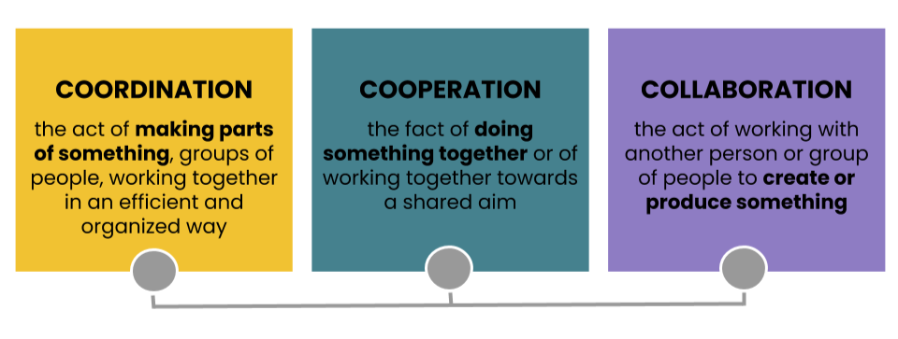
For more information, contact:
Ryan Oelrich, Priority Spokane Executive Director, (509)499-0536 or priorityspokane@outlook.com
Visit: www.PrioritySpokane.org and www.SpokaneTrends.org

